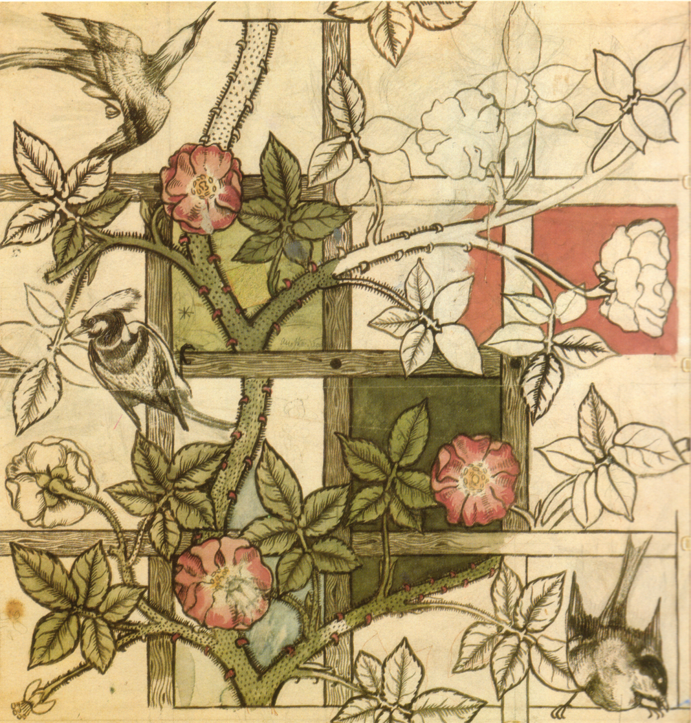

William Morris designs – Challenge: Copy the pattern on the left hand side onto the right hand side. Colour it

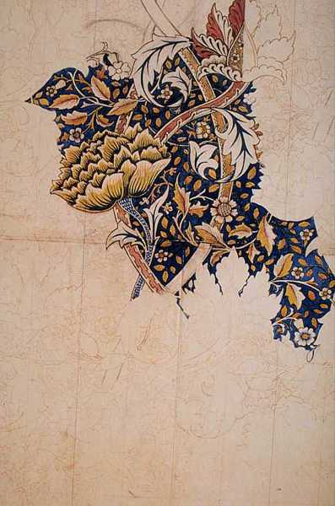

William Morris designs – Challenge: Copy the pattern on the left hand side onto the right hand side. Colour it

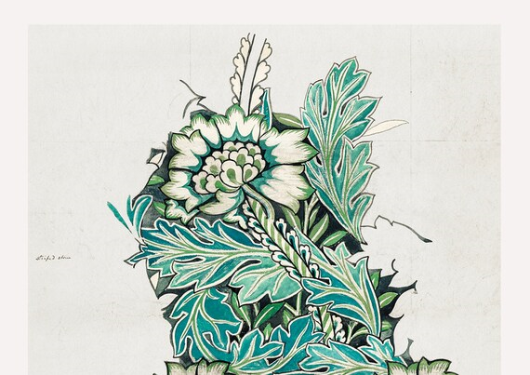

William Morris designs – Challenge: Copy the pattern on the left hand side onto the right hand side. Colour it. Add to it

